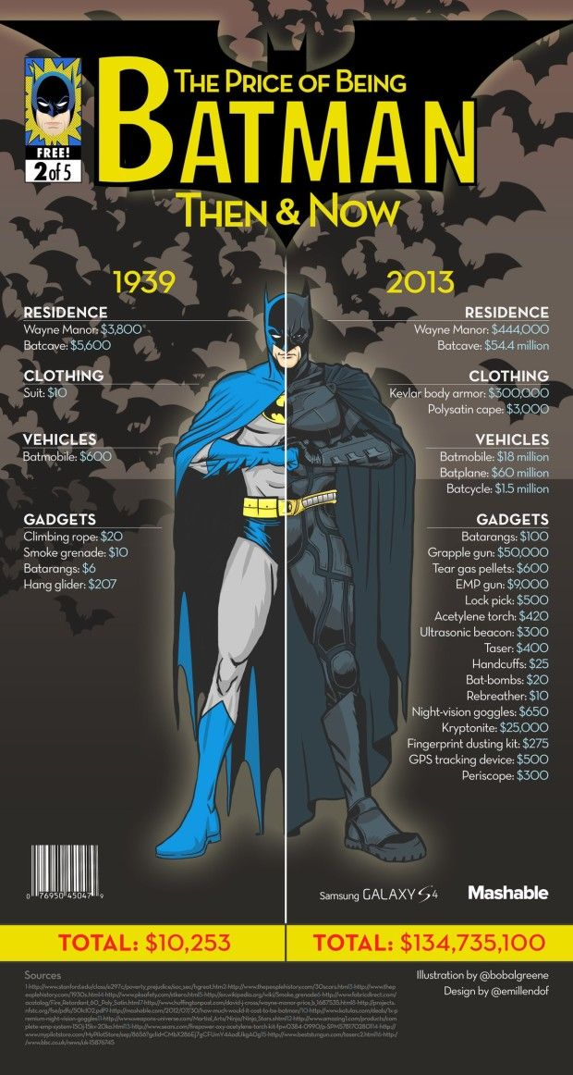
- How many years have passed between 1939 and 2013?
- How much more expensive is Wayne Manor now?

- What was the sum price of Batman’s gadgets in 1939?

- What was the total cost of Batman’s gadgets in 2013?

- What is the difference between the cost of Batman’s gadgets in 1939 and 2013?

- How much would four pairs of night vision goggles cost?

- How much change would I receive from $2,000 if I purchased 32 hang gliders?

- In 2013, what is the range of price difference between Batman’s most expensive and least expensive gadget?

- In 1939, what is the range of price difference between Batman’s most expensive and least expensive gadget?

- What was the total cost of being Batman in 1939?

- What was the total cost of being Batman in 2013?

- Why is being Batman in 2013 so much more expensive than being Batman in 1939?

