Educational Apps/Aplicaciones Educacionales
Spanish/Español Apps
- Spa Spanish lesson
- ABC Alfabetos
- Spanish First Words with Phonics
- Juana y Los Amigos De La Granja
- Count Spanish
- Ciencias Lite HD
- Blinka
- Spanish 123
- Spanish Alphabet
- Flash Apps Spanish Flash Cards
- ABC Español
- Sentence Builder (green)
- ABC Magico
English/Ingles Apps
- Flash Cards
- Lunchbox
- Little Jungle
- 3D ABC
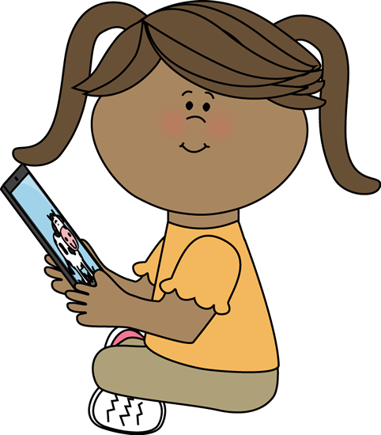
- eggzoo
- Jungle Animals
- EduKitchen
- Edupaintcc
- Eduroom
- Animal World
- babybits
- Tracing ABC
- Kinder Add
- Magnetic ABC
- StoryBots Learning Video
- Brain Pop Jr.
- Toy Story Read Along
- ABC Ninja
- Build a Word
- Hungry Monster
- ABC Magic
- Fruit ABCFree

